Data Analysis Case study

# Introduction

In this case study, you are presented with results from an A/B testing campaign we ran with a strategic customer.

For this campaign, the Brand **ACME** partnered with **SuperMalls** (our client) and **Quividi**.

The aim of this campaign is to convince ACME and other brands to buy more interactive campaigns, because they better engage customers.

An interactive campaign is a campaign that dynamically changes the content displayed on screen, to show the content most relevant to the demographic characteristics of the audience.

# Campaign design

ACME provided two kinds of contents :

* Their usual campaign, that ran as a control
* Contents that Quividi used to create an interactive campaign.

The test ran according to the following planning :

* 20 centers (malls) showed ACME’s content over a 4 week period.  
  During the first 2 weeks, all 20 centers showed the regular campaign.  
  During Weeks 3 and 4, 10 centers kept on showing the regular campaign, while the 10 other centers showed the interactive campaign.

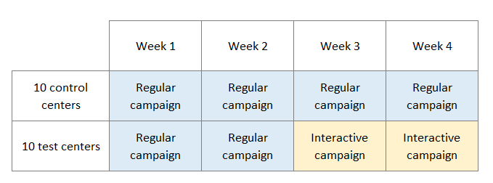

The aim of the study is to see the impact of the interactive campaign both on the audience, but also on the in store performance (are sales and traffic impacted ?)

During the campaign, the following data was collected

* Audience data (collected by Quividi on SuperMalls’ screens)
* Traffic data in store (provided by ACME)
* Sales : transaction and volume (provided by ACME).

These data are provided in individual CSV files.

As a data analyst, your role is to analyze this campaign, and find positive things to say, that would contribute to show that a triggered campaign is better than a regular campaign.

Please justify your choice of KPIs, and mention the statistical tests you use, if any.

**You should present the results in about 20 minutes**, preferably with slides.

Your audience is the marketing teams of ACME and SuperMalls, they are not technical.

A data analyst from SuperMalls may ask you technical questions after your presentation.

Here are a few questions to guide you :

* Why do you think the campaign was designed like this ?
* What KPIs did you choose ?
* Do you see any improvement on the audience / the store performance when the interactive campaign plays ?
* If there any correlation between the audience’s reaction to the campaign and the in-store performance ?
* Feel free to present the results in the way you prefer, and keep in mind that the results should be interesting, even for a non-technical audience !

Notes :

Attention time is the time spent by a person looking at the campaign. It is given in seconds.

Control centers = Centers 1 to 10

Test centers = Centers 11 to 20